Java with Angular (Full Stack Development)

MEAN – MongoDB, Express JS, Angular, Node

MERN – MongoDB, Express JS, React, Node

Full Stack

1. Java Full Stack
2. .Net Full Stack

Full Stack

1. Front End (UI – User Interface) – HTML, CSS, JS, BootStrap, Angular, React
2. Back End ( Server Side Coding) – Spring, SpringBoot, Servlet, JSP, JSF
3. Middle Layer (DB Layer) [SQL or NoSQL] – MySQL, Oracle, DB2, H2, Derby, Postgres
4. Operational Tools ( Docker, Jenkins, Kubernetes, Chef, puppet)
5. Testing Tools ( Sonar -Code Quality , Junit, Mockito)

DevOps – Development + Operations

DevSecOps – Development + Operations + Security

Project Titles

1. Travel Management System
2. Pension Management System
3. Online Shopping Portal
4. Hotel Booking Application
5. Online Banking
6. Bus Ticket Booking
7. School Management System
8. Movie Database System
9. OTT platform (Amazon prime, Netflix etc.,)

Technologies / Tools

1. Eclipse/STS/VS Code
2. JDK 8
3. Spring / Spring Boot (Data JPA)
4. Angular (Front End)
5. Postgres on RDS
6. SonarQube /Sonar Lint

Project Submission

1. Each Team needs to create a Single Github repository ( teamname_projectname)
2. Script.sql (Needs to contain all the SQL Queries – table creation and/or alter table queries), data.sql (It should contain all the insert queries)
3. README.md file with all the details about the project, like brief description about project, what are the assumptions made, what is the scope of the project, what will be the default url, types of users who can use this application.
4. Project Presentation (PPT) – Info about the project, team member details, Screen shots of the applications. Postman Testing Screen shots, Front End Screenshots
5. Login/Logout Functionality, profile update, forgot password, service Screen

Company Job Opportunities

1. Project Manager
2. Front End (UI-UX) Designers / Developers
3. Database Administrators (DBA)
4. Test Engineers
5. Backend Developers (Java/.Net/ PHP/ Python)
6. Data Scientist
7. DevOps Engineers

Now

1. Java/.Net Full – Stack Engineers
2. MEAN Stack Developers
3. MERN Stack Developers

Front End

1. HTML/CSS/JS (Bootstrap) --- Responsive Web Applications [Performance, Synchronous Mode – one operation at a time]
2. Using JS based Framework – Very Fast, Non-blocking(Asynchronous) – Multiple task at the same time --- callback – partial UI update, Very fast and responsive [Promises, Observables, Subjects] – AJAX (Angular/React/Vue …..)

Back End

1. Spring
2. Spring Boot (REST ful/SOAP based Web Service – Micro Service) (SOA – Service Oriented Architecture MSA – Micro Service Architecture)
3. Pension Management System
4. Online Shopping Portal
5. Hotel Booking Application
6. Online Banking
7. Bus Ticket Booking
8. School Management System

30 minutes every day – watch technical videos in youtube

Try to do coding for 30 minutes

Types of Engineer

1. Civil Engineer (Construction) –
2. Mechanical Engineer (Machinery)
3. Automobile Engineer
4. Computer / IT Engineer ( Laptop/Desktop with Internet Connection)

Spring MVC Application

Spring Web MVC Module -- Hibernate

Spring config file --- applicationContext.xml (or) any name.xml

Spring based web application should contain the web.xml (Deployment Descriptor)

Web.xml --- Is the starting point (or) Entry point of the web application

WAR – Web Archive (Compressed file with all Java source code & web content folder)

* [https://github.com/syskantechnosoft/Spring3MVCwithHibernate Download Spring3HibernateApp.war](https://github.com/syskantechnosoft/Spring3MVCwithHibernate%20Download%20Spring3HibernateApp.war) file from the above link.
* Open Eclipse
* Import Downloaded war file (File 🡪 Import 🡪 War 🡪 Choose the downloaded war file)

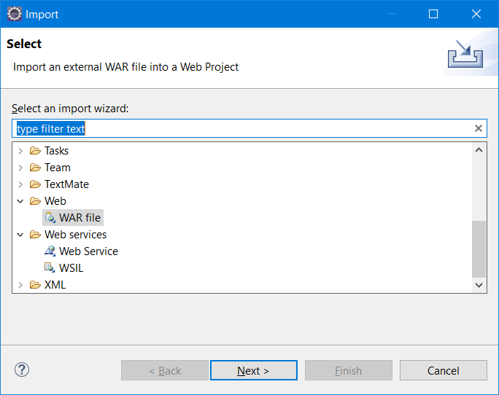

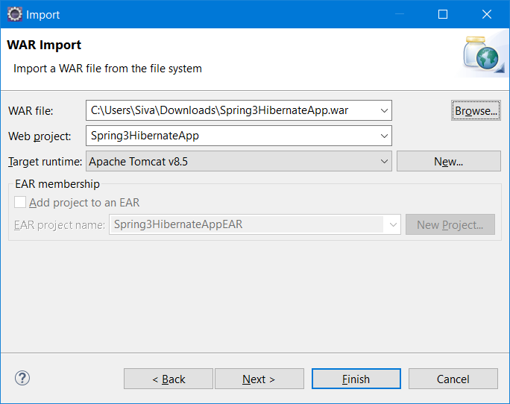

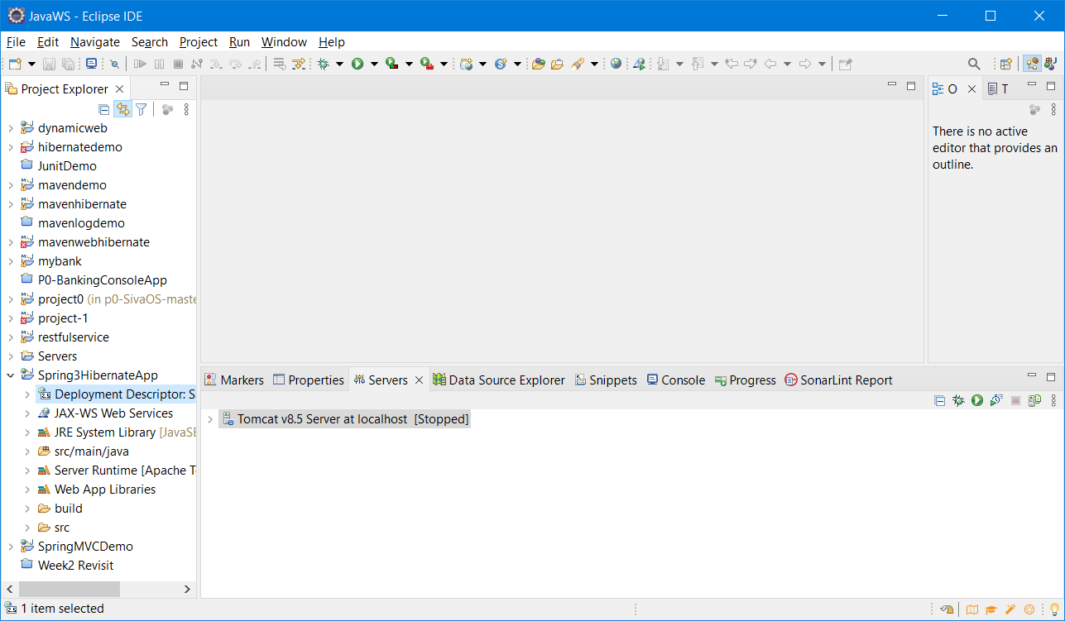

JPA Annotations

**@ID** -- For Primary Key (To make a column as primary key – to Inform the hibernate that the following column is the primary key of the table) – This is important (Must)

**@Entity** – To inform the JVM, the class is a Entity Bean Class (Must)

@Table --- To provide the database table name (Optional if table name and class name both same)

@Column -- To provide database column name, and other properties (It is optional if property name and column name both same)

Hibernate Annotations

@Table

@Tables

@Columns

Spring Web MVC

1. Web.xml (Entry Point)
2. Sdnext Location & servlet mapping (*.html)
3. Welcome file name is index.html ---(sdnext is applied)
4. Controller (Java Class) – ModelAndView (“index”)
5. Sdnext – apply prefix & suffix